**BOB THE HEADER**

**GAME DESIGN DOCUMENT**

1. **Project Overview**

*A 3D platformer game in which the player has to solve puzzles, dodge obstacles, collect coins and reach to the destination.*

**Version History**

|  |  |  |  |  |  |
| --- | --- | --- | --- | --- | --- |
| **Version #** | **Implemented**  **By** | **Revision**  **Date** | **Approved**  **By** | **Approval**  **Date** | **Reason** |
| 0.0.0.1 | *Pizza programmer* | *11/06/2023* | *Kalakaar [Lead]* | *11/06/2023* | *Initial version with player & its basic movements.* |
| 0.0.0.2 | *Pizza programmer* | *13/06/2023* | *Kalakaar [Lead]* | *13/06/2023* | *Moving platform, key & coin behavior* |
| 0.0.0.3 | *Vikey Soni(69)* | *14/06/2023* | *Kalakaar [Lead]* | *15/06/2023* | *Key model* |
| 0.0.0.4 | *Kalakaar* | *15/06/2023* | *Kalakaar [Lead]* | *15/06/2023* | *Tutorial level environment prototype* |
|  |  |  |  |  |  |
|  |  |  |  |  |  |
|  |  |  |  |  |  |

**Table of Contents**

1. ***Characters***
2. ***Story***
   1. ***Theme***
3. ***Story Progression***
4. ***Gameplay***
   1. ***Goal***
   2. ***User Skills***
   3. ***Game Mechanics***
   4. ***Core Mechanics***
   5. ***Items & powerups***
   6. ***Progression & Challenge***
   7. ***Losing***
5. ***Art style***
6. ***Music & Sounds***
7. ***Technical description***
8. ***Marketing & Funding***
   1. ***Demographics***
   2. ***Platforms & Monetization***
   3. ***Localization***
9. ***Other ideas***
10. **Characters**

***BOB the header*** *is the main character of this game. He has very big feet and he wears very big shoes on them.*

***Patrol enemies*** *are in the way of the protagonist to stop from reaching its goal.*

***Radius based enemies*** *who will act when player comes in their radius sphere.*

***JINGO*** *is a big monster and is the final boss who throws rocks.*

1. **Story**

*Once upon a time, there was a Stone Age man with very big feet who wore very big shoes on them. He was a nomad and used to break rocks & logs by jumping on them to make way for him to explore the world.*

*One day, a monster comes and steals his shoes while Bob was sleeping under a tree.*

*Now Bob has a mission to find that monster and take his shoes back from him, to do so, he need to solve puzzles, kill enemies that comes in his way to stop him and finally to defeat the monster and take his shoes back.*

1. ***Theme***

*Bob the header is a puzzle adventure game about a story of a Stone Age man whose shoes got stolen and he is trying to get them back.*

*Adventure | Story | puzzle*

1. **Story Progression**

*The game starts with a scene in which Bob is sleeping under a tree with his shoes by his side, after a while, a monster comes and steals his shoes. Bob tries to find his shoes after he wakes up but he don’t see them anywhere.*

*Bob navigates through* ***jungle environment*** *by moving, jumping, killing jungle enemies & breaking rocks and logs in his way collecting coins till he finds a locked cave which needs a key that is to be found by Bob to progress further.*

*Next, Bob has to explore the* ***cave environment*** *and find his way out by avoiding traps, solving puzzles, collecting coins, killing cave enemies and finding a key which unlocks the cave exit which leads to mountain environment.*

*Next, Bob has to explore the* ***mountain environment*** *and find his way to the top of the mountain by avoiding traps, collecting coins and killing mountain enemies. On top of the mountain Bob will fight the final boss and take his shoes back form him. This will be the final level of the game.*

Jungle level

Cave Level

Mountain level

1. **Gameplay**

*Gameplay will be from a third person perspective.*

**4.1. Goals**

*Overall (Long term) goal: To snatch back Bob’s shoes from* ***JINGO***

*Gameplay (Short term) goals:*

1. *Level 1: Find a key to unlock cave door.*
2. *Level 2: Find a key to unlock exit door of the cave.*
3. *Level 3: Navigate to the top of mountain to meet and fight JINGO [BOSS].*

**4.2. User Skills**

* 1. *Moving around*
     + *Forward, backward, left, right [W A S D]*
     + *Jump [SPACE]*
     + *Jump on the heads of enemies to kill them.*
  2. *Breaking things*
     + *Bob can break certain things by jumping on them.*
     + *Like: small rocks & tree logs but not big ones.*
  3. *Collect items*
     + *Coins[for now]*
     + *Keys*
     + *Powerups*

***4.3. Game Mechanics***

***4.3.1. Player***

*Refer to section 4.2 user skills.*

|  |  |  |  |  |
| --- | --- | --- | --- | --- |
| ***Name*** | ***Height*** | ***HP*** | ***Lives*** | ***Attack damage*** |
| *Bob* | *1 unity unit* | *3* | *3* | *1 [default]* |

*Concept art reference images for Bob & his shoes:*

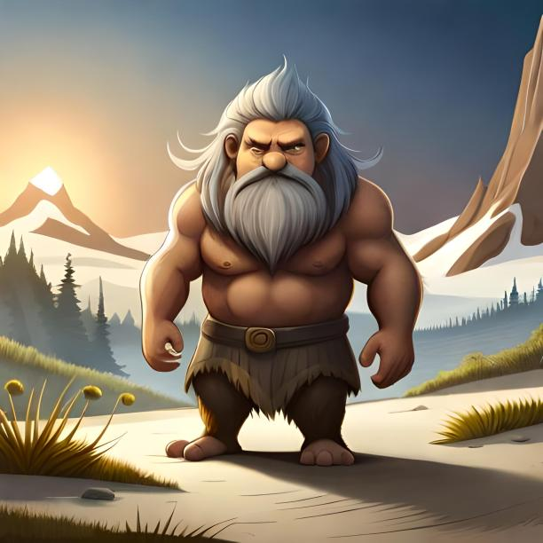 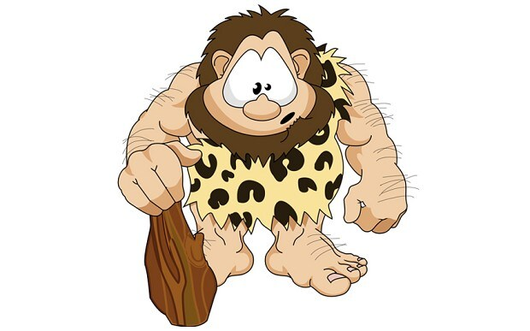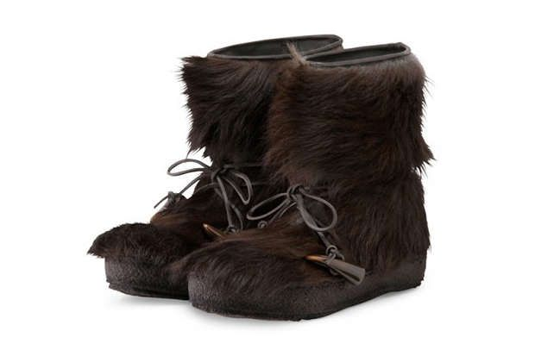

Note: Bob’s feet will be bigger than the reference image and he will be wearing his shoes only in the starting cut scene. Also he won’t be holding any weapon in his hands. Both shoes and Bob’s models are separate.

***4.3.2. Enemies***

|  |  |  |  |  |  |
| --- | --- | --- | --- | --- | --- |
| ***Enemy*** | ***What they do*** | ***description*** | ***HP*** | ***Give damage of*** | ***Take damage of*** |
| *Guards*  *[temp. name]* | *Patrol only* | *Patrol on a defined path and is fast.* | *In the range of 1 to 3 randomized* | *1* | *1* |
| *Rangers*  *[temp. name]* | *Radius based* | *Patrol on a defined path but Throws sticks towards player when in range.* ***Standing enemy*** | *In the range of 4 to 6 randomized* | *3* | *1* |
| *Brutes* | *Radius based* | *Follows player when Bob is in its range.* | *3* | *2* | *1* |

***4.3.3. Collectables***

|  |  |  |  |
| --- | --- | --- | --- |
| ***Name*** | ***Type*** | ***What does it do?*** | ***Where to find*** |
| *Key* | *Mandatory* | *Open gate to next area/level* | *A secret area* |
| *Coin* | *Optional* | *Currency to buy things [players, skins etc.]* | *Throughout the level & when rocks or logs are crushed.* |

***4.3.4. Platforms***

|  |  |
| --- | --- |
| ***Types of the platform*** | ***What does it do?*** |
| *Normal* | *Ground platforms. Stay idle.* |
| *Floating* | *Float in air.* |
| *Floating + Moving* | *Float along a defined path.* |

***4.3.5. Obstacles***

|  |  |
| --- | --- |
| ***Name*** | ***Type*** |
| *Boulders [4-5x the size of player]* | *Non destructible* |
| *Big logs* | *Non destructible* |
| *Fallen trees* | *Non destructible* |
| *Rocks[1x the size of player]* | *Destructible* |
| *Small hollow logs[2x the size of player]* | *Destructible* |

***4.4. Core Mechanics***

* *Walk*
* *Jump*
* *Destroy things by jumping on their head/top.*

***4.5. Items and Power-ups***

|  |  |  |  |
| --- | --- | --- | --- |
| ***Name*** | ***Work*** | ***Where to find*** | ***Lasts*** |
| *Jump boost* | *Temporarily increases the jump eight [2x].* | *Before a parkour part of the level* | *10 seconds* |
| *Damage boost* | *Temporarily increases the damage given by jumping on the heads of enemies.* | *Where player have to fight 4-5 enemies simultaneously and in boss fights.* | *15 seconds* |
| *Health* | *+1 HP* | *Specific places.* | *Permanent* |

Player perspective reference: Camera should be a little bit more zoomed in.

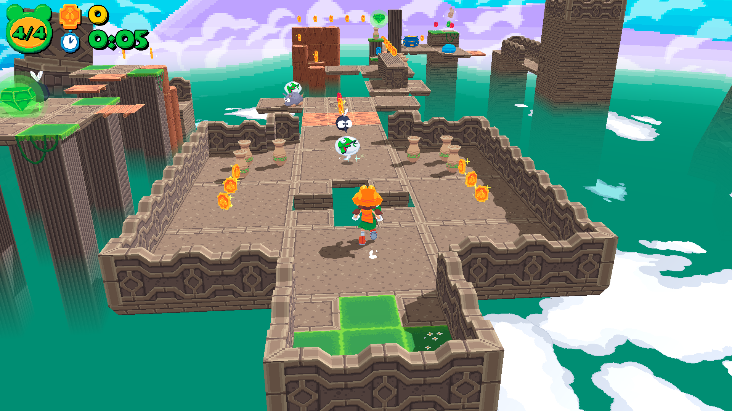

1. **Art Style**

* Low poly but cartoony style.

Mood and environment reference images:

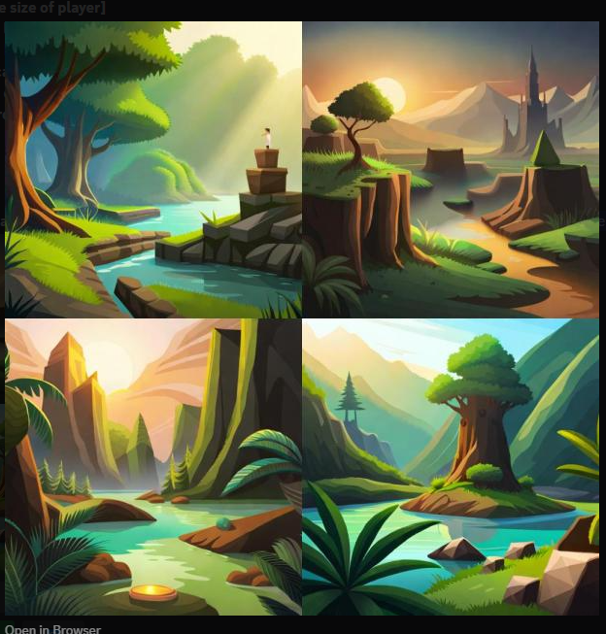

1. **Music & Sounds**

**7.1 Player Sounds:**

* Walk [ footsteps ]
* Jump
* Kill
* Excited sound when key is found
* Win
* Reference: https://elements.envato.com/caveman-happy-vocal-expression-Z87K2WV

**7.2 Enemy Sounds:**

* Patrol
* Hurt
* Die

**7.3 Music**

* Menu background music
* In-game theme song

1. **Technical Description**

**8.1 Platforms Supported:**

* Window
* Mac OS
* Linux

1. **Marketing**

**9.1 Promotions:**

* Facebook posts
* Instagram posts
* YouTube channel

**9.2** **Demographics:**

* Age: 9+
* Gender: Anyone
* Casual players mostly